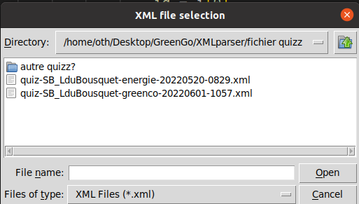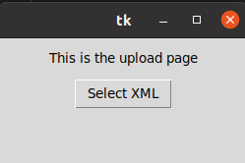**USER GUIDE**

Clicking this box allows you to chose the desired XML file

You then choose the desired file

After choosing the file you will be presented with the following window:

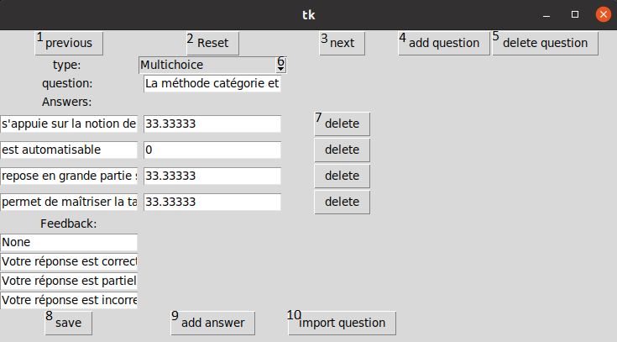

1. Returns to the previous question
2. Returns to the initial window to choose another XML file
3. Goes to the next question
4. 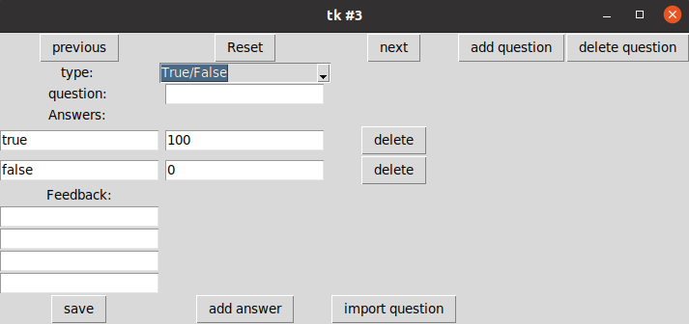Adds a new question
5. Deletes the question
6. 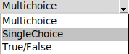Chose the type of the question
7. Delete the answer
8. Saves any changes made to the question
9. Adds a new field for an answer
10. Adds the current question to the database